**Week 2 Project: Docker Containers**

**Step 1: Download MongoDB Image for Docker**

1. Your Docker service needs to be active and running. You can quickly check the current status by entering the following command in your terminal:

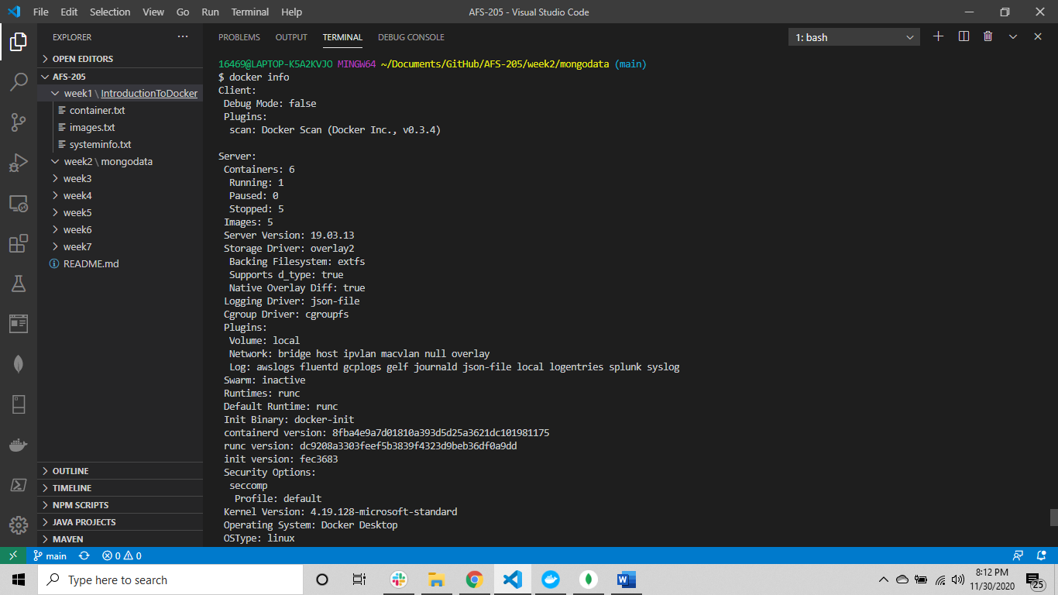

2. Proceed to download the latest official Docker image for the MongoDB database:

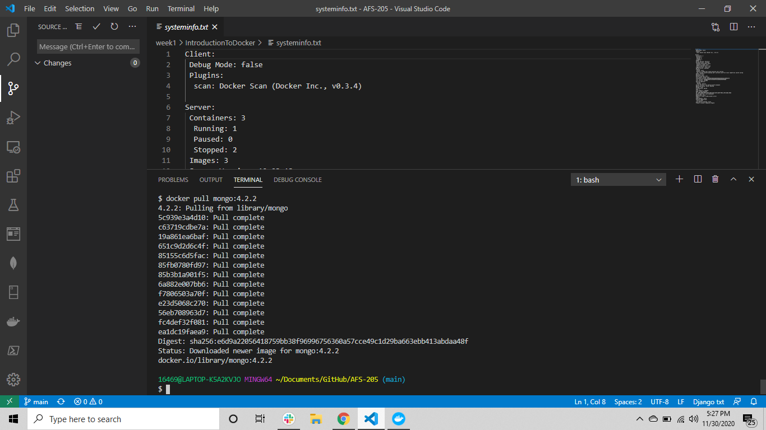

3.List the images in your Docker repository with the following command:

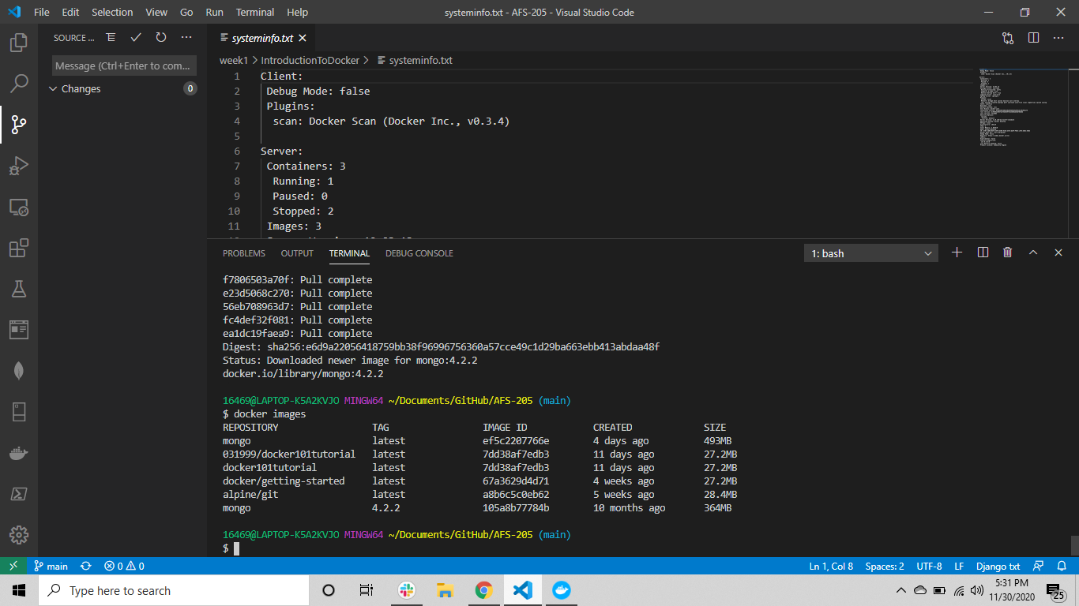

4. a- Create a **/mongodata** directory on the host system:  
In Winows OS:

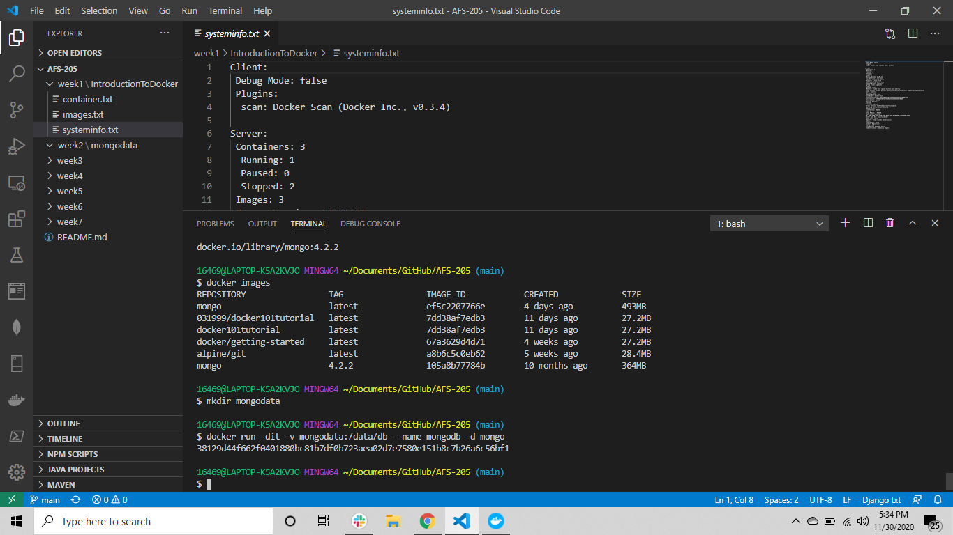

5. Start the Docker container with the **run** command using the mongo image. The **/data/db** directory in the container is mounted as **/mongodata** on the host. Additionally, this command changes the name of the container to *mongodb*:

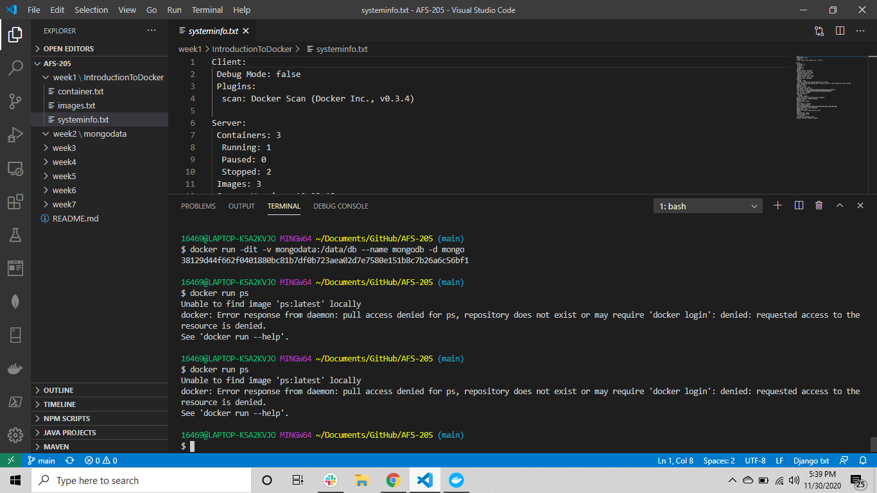

6. Once the MongoDB server starts running in a container

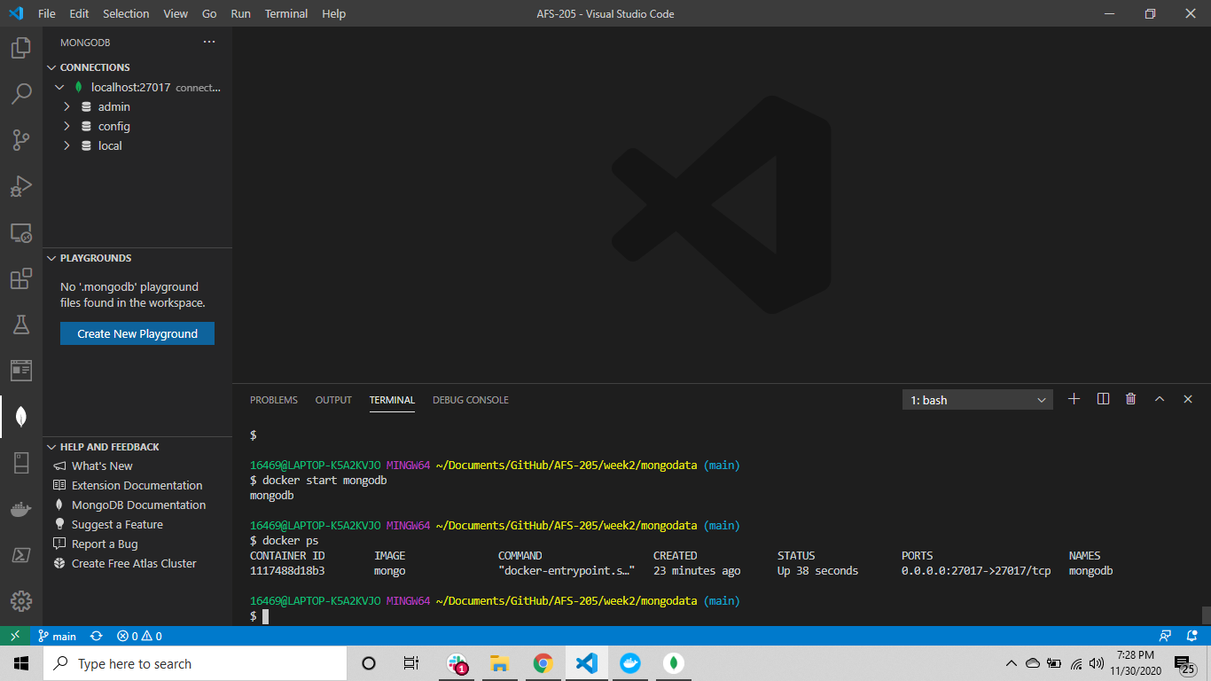

7. Optionally you can specify the MongoDB port explicitly:  
The default port number is **27017*,*** as can be seen in the output***.***

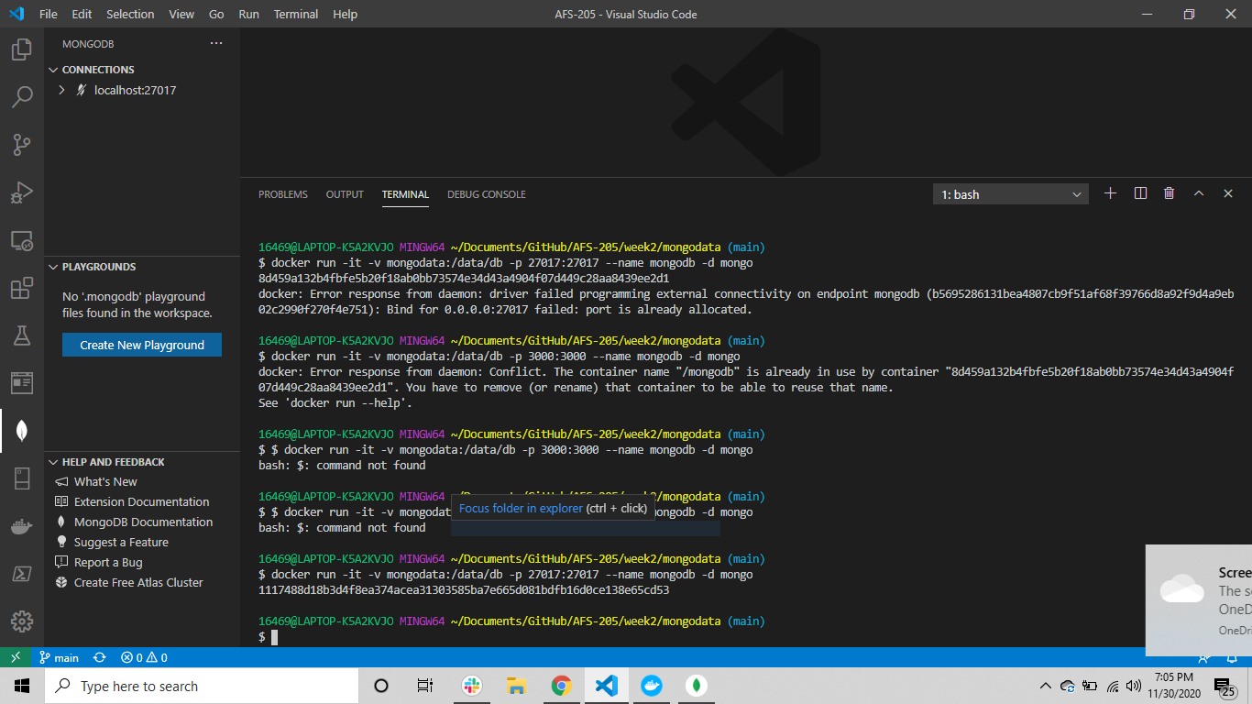

8. Always check the Docker log to see the chain of events after making changes.

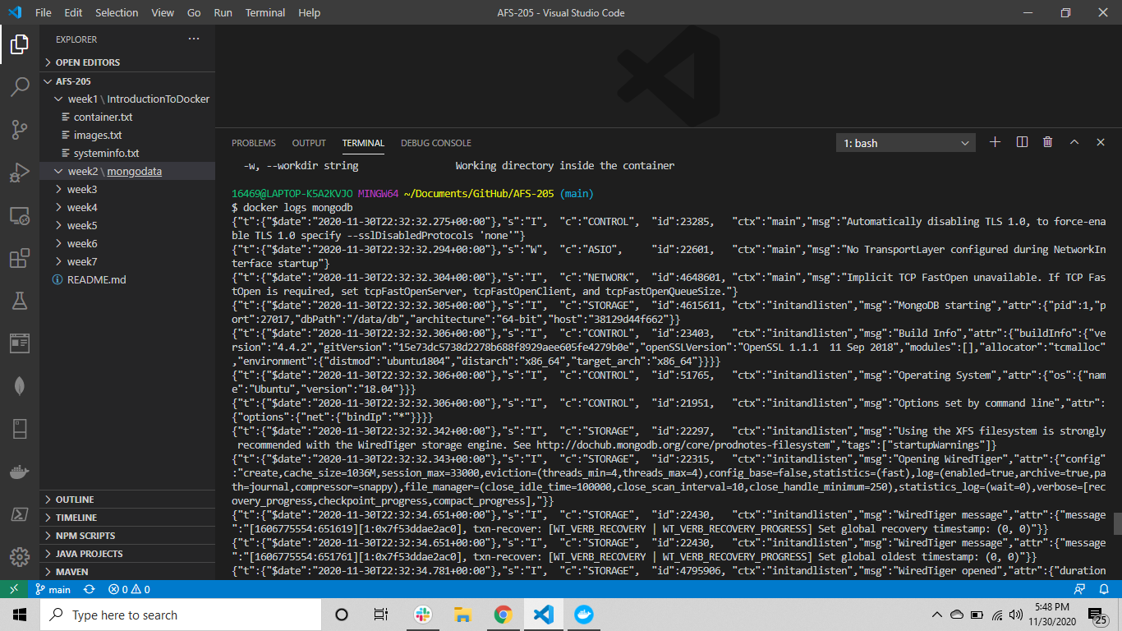

9. The container is currently running in **a detached mode**. Connect to the container using the interactive terminal instead:

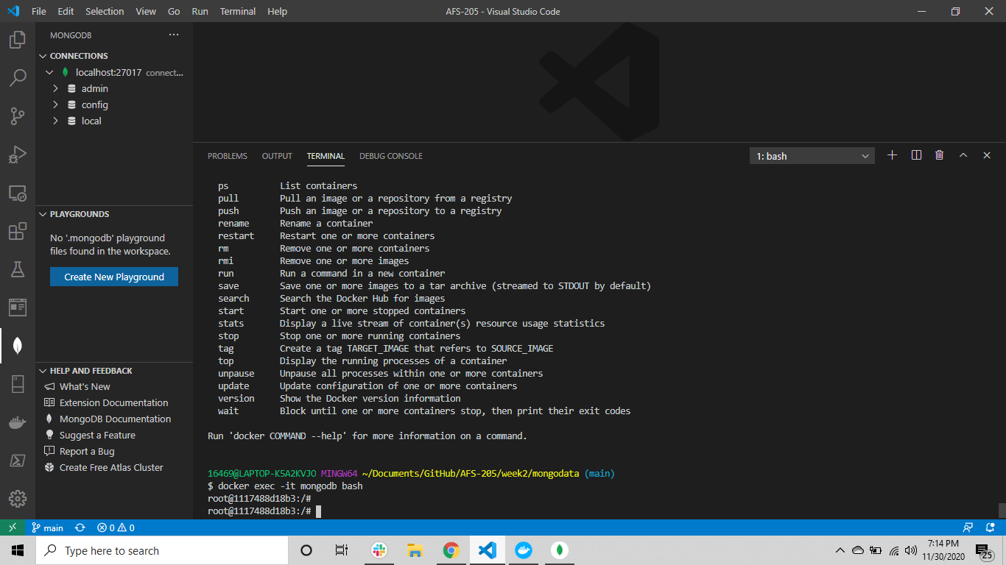

10. Default Database

Show dbs

11. Create Database

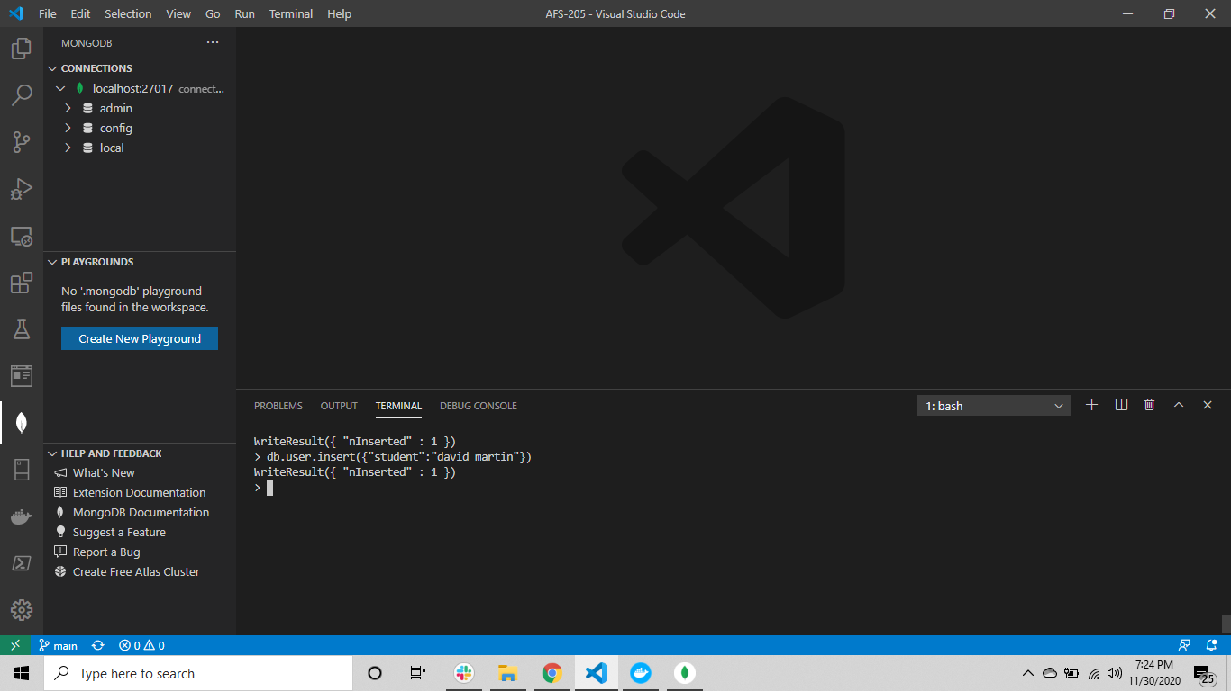

12. Insert Database

